**JAVA ASSIGNMENT COLLECTIONS**

1.) import java.util.*;

public class Main

{

public static void main(String[] args) {

List<String> ls = new ArrayList<String>();

ls.add("Black");

ls.add("Pink");

ls.add("Blue");

ls.add("Yellow");

ls.add("Green");

System.out.println(ls);

}

}

Output:

2.) import java.util.*;

public class Main

{

public static void main(String[] args) {

List<String> ls = new ArrayList<String>();

ls.add("Black");

ls.add("Pink");

ls.add("Blue");

ls.add("Yellow");

ls.add("Green");

for (String e : ls) {

System.out.println(e);

}

}

}

Output:

3.) import java.util.*;

public class Main

{

public static void main(String[] args) {

List<String> ls = new ArrayList<String>();

ls.add("Black");

ls.add("Pink");

ls.add("Blue");

ls.add("Yellow");

ls.add("Green");

ls.add(0, "Red");

System.out.println(ls);

}

}

Output:

4.) import java.util.*;

public class Main

{

public static void main(String[] args) {

List<String> ls = new ArrayList<String>();

ls.add("Black");

ls.add("Pink");

ls.add("Blue");

ls.add("Yellow");

ls.add("Green");

System.out.println(ls);

String element = ls.get(1);

System.out.println("Second element: "+element);

element = ls.get(2);

System.out.println("Third element: "+element);

}

}

Output:

5.) import java.util.*;

public class Main

{

public static void main(String[] args) {

List<String> ls = new ArrayList<String>();

ls.add("Black");

ls.add("Pink");

ls.add("Blue");

ls.add("Yellow");

ls.add("Green");

System.out.println(ls);

ls.set(4, "Red");

System.out.println(ls);

}

}

Output:

6.) import java.util.*;

public class Main

{

public static void main(String[] args) {

List<String> ls = new ArrayList<String>();

ls.add("Black");

ls.add("Pink");

ls.add("Blue");

ls.add("Yellow");

ls.add("Green");

System.out.println(ls);

ls.remove(2);

System.out.println("After removing third element from list : "+ls);

}

}

Output:

7.) import java.util.*;

public class Main

{

public static void main(String[] args) {

List<String> ls = new ArrayList<String>();

ls.add("Black");

ls.add("Pink");

ls.add("Blue");

ls.add("Yellow");

ls.add("Green");

if (ls.contains("Blue"))

System.out.println("Found the element");

else

System.out.println("There is no such element");

}

}

Output:

8.) import java.util.*;

public class Main

{

public static void main(String[] args) {

List<String> ls = new ArrayList<String>();

ls.add("Black");

ls.add("Pink");

ls.add("Blue");

ls.add("Yellow");

ls.add("Green");

System.out.println("Before sorting : "+ls);

Collections.sort(ls);

System.out.println("After sorting : "+ls);

}

}

Output:

9.) import java.util.*;

public class Main

{

public static void main(String[] args) {

List<String> ls = new ArrayList<String>();

ls.add("Black");

ls.add("Pink");

ls.add("Blue");

ls.add("Yellow");

ls.add("Green");

System.out.println("First list : "+ls);

List<String> ls2 = new ArrayList<String>();

ls2.add("1");

ls2.add("2");

ls2.add("3");

ls2.add("4");

ls2.add("5");

System.out.println("Second list: " + ls2);

Collections.copy(ls, ls2);

System.out.println("After copying:");

System.out.println("List 1: " + ls);

System.out.println("List 2: " + ls2);

}

}

Output:

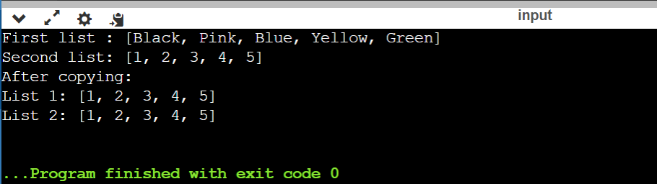

10.) import java.util.*;

public class Main

{

public static void main(String[] args) {

List<String> ls = new ArrayList<String>();

ls.add("Black");

ls.add("Pink");

ls.add("Blue");

ls.add("Yellow");

ls.add("Green");

System.out.println("Before shuffling : " + ls);

Collections.shuffle(ls);

System.out.println("After shuffling : " + ls);

}

}

Output:

11.) import java.util.*;

public class Main

{

public static void main(String[] args) {

List<String> ls = new ArrayList<String>();

ls.add("Black");

ls.add("Pink");

ls.add("Blue");

ls.add("Yellow");

ls.add("Green");

System.out.println("Before reversing : " + ls);

Collections.reverse(ls);

System.out.println("After reversing : " + ls);

}

}

Output:

12.) import java.util.*;

public class Main

{

public static void main(String[] args) {

ArrayList<String> ls = new ArrayList<String>();

ls.add("Black");

ls.add("Pink");

ls.add("Blue");

ls.add("Yellow");

ls.add("Green");

System.out.println("Before cloning : " + ls);

ArrayList<String> ls2 = (ArrayList<String>)ls.clone();

System.out.println("After cloning : " + ls2);

}

}

Output:

13.) import java.util.*;

public class Main

{

public static void main(String[] args) {

ArrayList<String> ls = new ArrayList<String>();

ls.add("Black");

ls.add("Pink");

ls.add("Blue");

ls.add("Yellow");

ls.add("Green");

System.out.println("Before emptying : " + ls);

ls.removeAll(ls);

System.out.println("After emptying : "+ls);

}

}

Output:

14.) import java.util.*;

public class Main

{

public static void main(String[] args) {

ArrayList<String> ls = new ArrayList<String>();

ls.add("Black");

ls.add("Pink");

ls.add("Blue");

ls.add("Yellow");

ls.add("Green");

System.out.println("Original list : " + ls);

String new_color = "White";

ls.set(1,new_color);

int num=ls.size();

System.out.println("Replace second element with 'White'.");

for(int i=0;i<num;i++)

System.out.println(ls.get(i));

}

}

Output:

15.) import java.util.*;

public class Main

{

public static void main(String[] args) {

ArrayList<String> ls = new ArrayList<String>();

ls.add("Black");

ls.add("Pink");

ls.add("Blue");

ls.add("Yellow");

ls.add("Green");

System.out.println("Checking if the above array list is empty or not : "+ls.isEmpty());

ls.removeAll(ls);

System.out.println("Array list after removing all elements : "+ls);

System.out.println("Checking the above array list is empty or not "+ls.isEmpty());

}

}

Output:

16.) import java.util.*;

public class Main

{

public static void main(String[] args) {

LinkedList<String> ls = new LinkedList<String>();

ls.add("Black");

ls.add("Pink");

ls.add("Blue");

ls.add("Yellow");

ls.add("Green");

System.out.println("Linked list : "+ls);

}

}

Output:

17.) import java.util.*;

public class Main

{

public static void main(String[] args) {

LinkedList<String> ls = new LinkedList<String>();

ls.add("Black");

ls.add("Pink");

ls.add("Blue");

ls.add("Yellow");

ls.add("Green");

Iterator p = ls.listIterator(0);

while (p.hasNext()) {

System.out.println(p.next());}

}

}

Output:

18.) import java.util.*;

public class Main

{

public static void main(String[] args) {

LinkedList<String> ls = new LinkedList<String>();

ls.add("Black");

ls.add("Pink");

ls.add("Blue");

ls.add("Yellow");

ls.add("Green");

Iterator p = ls.listIterator(3);

while (p.hasNext()) {

System.out.println(p.next());}

}

}

Output:

19.) import java.util.*;

public class Main

{

public static void main(String[] args) {

LinkedList<String> ls = new LinkedList<String>();

ls.add("Black");

ls.add("Pink");

ls.add("Blue");

ls.add("Yellow");

ls.add("Green");

System.out.println("Original linked list:" + ls);

LinkedList <String> ls2 = new LinkedList <String> ();

ls2.add("Grey");

ls.addAll(1, ls2);

System.out.println("After adding : " + ls);

}

}

Output:

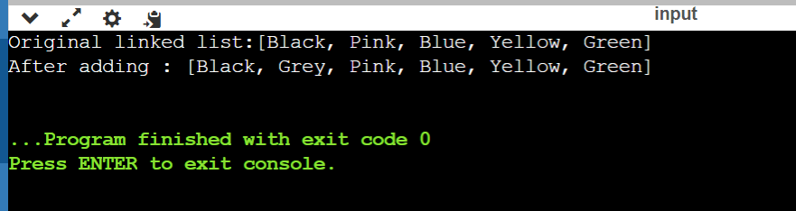

20.) import java.util.*;

public class Main

{

public static void main(String[] args) {

LinkedList<String> ls = new LinkedList<String>();

ls.add("Black");

ls.add("Pink");

ls.add("Blue");

ls.add("Yellow");

ls.add("Green");

System.out.println("Original linked list:" + ls);

for(int i=0; i < ls.size(); i++)

{

System.out.println("Element at index "+i+": "+ls.get(i));

}

}

}

Output:

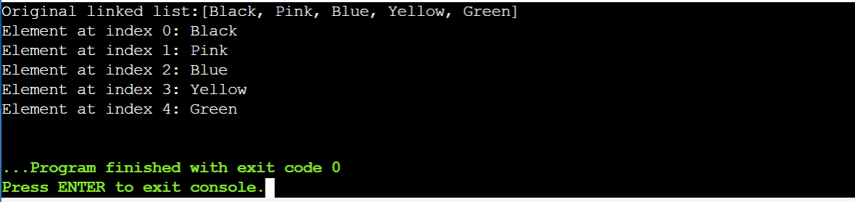

21.) import java.util.*;

public class Main

{

public static void main(String[] args) {

LinkedList<String> ls = new LinkedList<String>();

ls.add("Black");

ls.add("Pink");

ls.add("Blue");

ls.add("Yellow");

ls.add("Green");

System.out.println("Original linked list:" + ls);

Collections.swap(ls, 2, 3);

System.out.println("After swapping : " + ls);

}

}

Output:

22.) import java.util.*;

public class Main

{

public static void main(String[] args) {

HashSet<String> ls = new HashSet<String>();

ls.add("Black");

ls.add("Pink");

ls.add("Blue");

ls.add("Yellow");

ls.add("Green");

System.out.println("Hash set :" + ls);

}

}

Output:

23.) import java.util.*;

public class Main

{

public static void main(String[] args) {

HashSet<String> ls = new HashSet<String>();

ls.add("Black");

ls.add("Pink");

ls.add("Blue");

ls.add("Yellow");

ls.add("Green");

System.out.println("Hash set :" + ls);

Iterator<String> a = ls.iterator();

while (a.hasNext()) {

System.out.println(a.next());

}

}

}

Output:

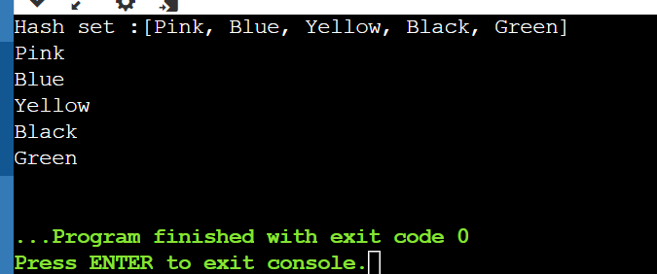

24.) import java.util.*;

public class Main

{

public static void main(String[] args) {

HashSet<String> ls = new HashSet<String>();

ls.add("Black");

ls.add("Pink");

ls.add("Blue");

ls.add("Yellow");

ls.add("Green");

System.out.println("Hash set :" + ls);

ls.removeAll(ls);

System.out.println("After emptying the hash set : "+ ls);

}

}

Output:

25.) import java.util.*;

public class Main

{

public static void main(String[] args) {

HashSet<String> ls = new HashSet<String>();

ls.add("Black");

ls.add("Pink");

ls.add("Blue");

ls.add("Yellow");

ls.add("Green");

System.out.println("Hash set :" + ls);

String[] arr = new String[ls.size()];

ls.toArray(arr);

System.out.println("Array elements are : ");

for(String element : arr){

System.out.println(element);}

}

}

Output:

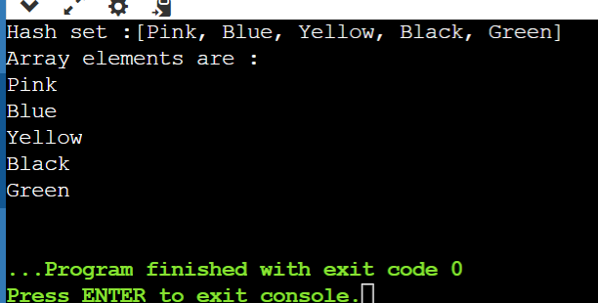

26.) import java.util.*;

public class Main

{

public static void main(String[] args) {

HashSet<String> ls = new HashSet<String>();

ls.add("Black");

ls.add("Pink");

ls.add("Blue");

ls.add("Yellow");

ls.add("Green");

System.out.println("Hash set no.1 :" + ls);

HashSet<String>ls2 = new HashSet<String>();

ls2.add("Golden");

ls2.add("Silver");

ls2.add("Black");

System.out.println("Hash set no.2 : "+ ls2);

ls.retainAll(ls2);

System.out.println("After retaining :");

System.out.println(ls);

}

}

Output:

27.) import java.util.*;

public class Main

{

public static void main(String[] args) {

TreeSet<String> ts = new TreeSet<String>();

ts.add("Black");

ts.add("Pink");

ts.add("Blue");

ts.add("Yellow");

ts.add("Green");

for (String element : ts) {

System.out.println(element);

}

}

}

Output:

28.) import java.util.*;

public class Main

{

public static void main(String[] args) {

TreeSet<String> ts = new TreeSet<String>();

ts.add("Black");

ts.add("Pink");

ts.add("Blue");

ts.add("Yellow");

ts.add("Green");

System.out.println(ts);

Object first_element = ts.first();

System.out.println("First Element : "+ first_element);

Object last_element = ts.last();

System.out.println("Last Element : "+ last_element);

}

}

Output:

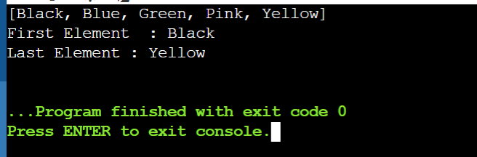

29.) import java.util.*;

public class Main

{

public static void main(String[] args) {

TreeSet <Integer>ts = new TreeSet<Integer>();

ts.add(10);

ts.add(20);

ts.add(30);

ts.add(40);

ts.add(50);

System.out.println(ts);

System.out.println("Less than 30 : "+ts.lower(30));

}

}

Output:

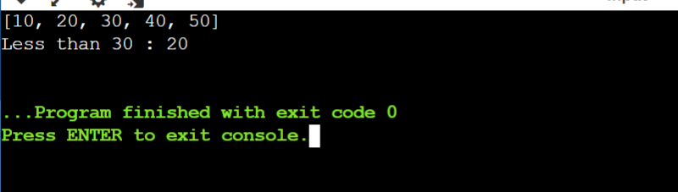

30.) import java.util.*;

public class Main

{

public static void main(String[] args) {

TreeSet <Integer>ts = new TreeSet<Integer>();

ts.add(10);

ts.add(20);

ts.add(30);

ts.add(40);

ts.add(50);

System.out.println(ts);

ts.remove(30);

System.out.println("After removing 30 from the tree set : "+ts);

}

}

Output:

31.) import java.util.*;

public class Main

{

public static void main(String[] args) {

HashMap<Integer,String> hm = new HashMap<Integer,String>();

hm.put(10,"AAAA");

hm.put(20,"BBBB");

hm.put(30,"CCCC");

hm.put(40,"DDDD");

hm.put(50,"EEEE");

for(Map.Entry x:hm.entrySet()){

System.out.println(x.getKey()+" "+x.getValue());

}

}

}

Output:

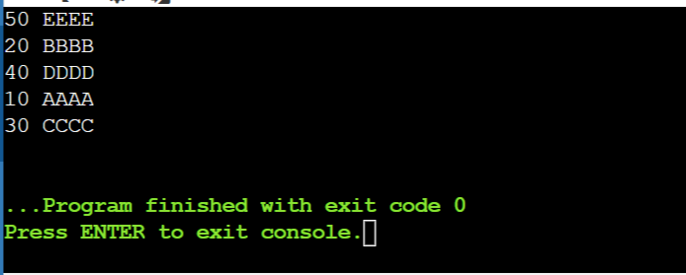

32.) import java.util.*;

public class Main

{

public static void main(String[] args) {

HashMap<Integer,String> hm = new HashMap<Integer,String>();

hm.put(10,"AAAA");

hm.put(20,"BBBB");

hm.put(30,"CCCC");

hm.put(40,"DDDD");

hm.put(50,"EEEE");

System.out.println("Size of hash map : "+hm.size());

}

}

Output:

33.) import java.util.*;

public class Main

{

public static void main(String[] args) {

HashMap<Integer,String> hm = new HashMap<Integer,String>();

HashMap <Integer,String> hm2 = new HashMap <Integer,String> ();

hm.put(10,"AAAA");

hm.put(20,"BBBB");

hm.put(30,"CCCC");

hm.put(40,"DDDD");

hm.put(50,"EEEE");

System.out.println("Values of hash map no.1 : " + hm);

hm2.put(70,"zzzz");

hm2.put(80,"xxxx");

System.out.println("Values of hash map no.2 : " + hm2);

hm2.putAll(hm);

System.out.println("New hash map no.2 : " + hm2);

}

}

Output:

34.) import java.util.*;

public class Main

{

public static void main(String[] args) {

HashMap<Integer,String> hm = new HashMap<Integer,String>();

hm.put(10,"AAAA");

hm.put(20,"BBBB");

hm.put(30,"CCCC");

hm.put(40,"DDDD");

hm.put(50,"EEEE");

boolean result = hm.isEmpty();

System.out.println("Is the hash map empty : " + result);

hm.clear();

result = hm.isEmpty();

System.out.println("Is hash map empty : " + result);

}

}

Output:

35.) import java.util.*;

public class Main

{

public static void main(String[] args) {

HashMap<Integer,String> hm = new HashMap<Integer,String>();

hm.put(10,"AAAA");

hm.put(20,"BBBB");

hm.put(30,"CCCC");

hm.put(40,"DDDD");

hm.put(50,"EEEE");

System.out.println("Hash map : " + hm);

System.out.println("Checking if key 'DDDD' is present in the hash map :");

if (hm.containsKey("DDDD")) {

System.out.println("Yes its present ");

} else {

System.out.println("no its not present");

}

System.out.println("Checking if key '20' is present in the hash map :");

if (hm.containsKey(20)) {

System.out.println("Yes its present ");

} else {

System.out.println("no its not present");

}

}

}

Output:

36.) import java.util.*;

public class Main

{

public static void main(String[] args) {

HashMap<Integer,String> hm = new HashMap<Integer,String>();

hm.put(10,"AAAA");

hm.put(20,"BBBB");

hm.put(30,"CCCC");

hm.put(40,"DDDD");

hm.put(50,"EEEE");

System.out.println("Hash map : " + hm);

System.out.println("Checking if '10,AAAA' is present in the hash map :");

if (hm.containsValue("AAAA")) {

System.out.println("Yes its present ");

} else {

System.out.println("no its not present");

}

}

}

Output:

